**DIRECCION DE AGRICULTURA, GANADERIA Y DESARROLLO RURAL DEL MUNICIPIO DE JOCOTEPEC JALISCO.**

**CONGREGACION MARIANA TRINITARIA**

CONCEPTOS SUBSIDIADOS PARA GRUPOS COMUNITARIO

|  |  |
| --- | --- |
| **CAPACIDAD CISTERNAS** | **PRECIO SUBSIDIADO** |
| 1,200 litros | $3,450 |
| 2,800 litros | $7,180 |
| 5,000 litros | $13,050 |
| 10,000 litros | $28,800 |

|  |  |
| --- | --- |
| **CAPACIDAD TINACOS** | **PRECIO SUBSIDIADO** |
| 450 litros | $1,550 |
| 600 litros | $1,870 |
| 750 litros | $2,150 |
| 1,100 litros | $2,250 |
| 2,500 litros | $5,090 |

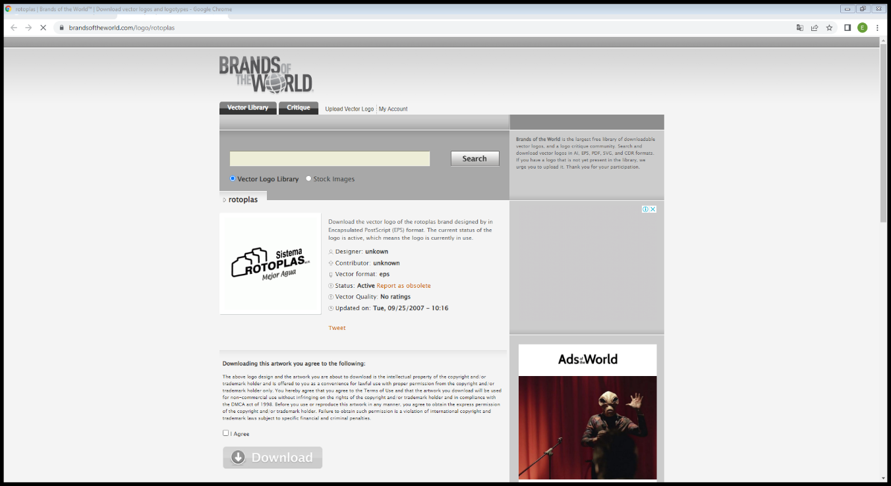

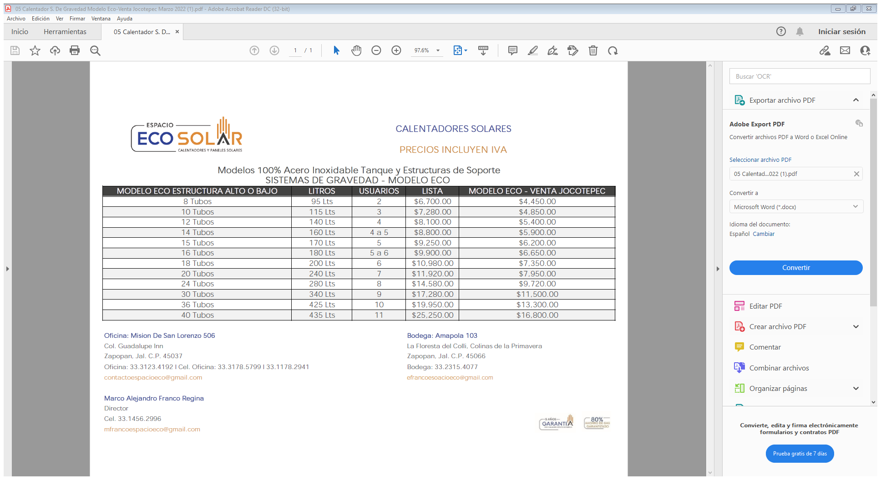

Modelo 100% Acero Inoxidable Tanque y Estructuras de Soporte

SISTEMAS DE GRAVEDAD – MODELO ECO

|  |  |  |  |  |
| --- | --- | --- | --- | --- |
| **MODELO ECO ESTRUCTURA ALTO O BAJO** | **LITROS** | **USUARIOS** | **LISTA** | **MODELO ECO- VENTA JOCOTEPEC** |
| 8 | 95 | 2 | $6,700 | $3,750 |
| 10 | 115 | 3 | $7,280 | $4,120 |
| 12 | 140 | 4 | $8,100 | $4,600 |
| 15 | 170 | 5 | $9,250 | $5,400 |
| 18 | 200 | 6 | $10,980 | $6,200 |
| 20 | 240 | 7 | $11,920 | $7,200 |
| 24 | 280 | 8 | $14,580 | $9,100 |
| 30 | 340 | 9 | $17,280 | $9,750 |
| 36 | 425 | 10 | $19,950 | $12,450 |

